NLP LAB ASSIGNMENT 2:
Name:V.Nithya
Hall ticket no:2403A52346
Batch:13
Question:
Aim: Apply preprocessing to sensitive medical or healthcare-related text.
Activities:
- Load medical text corpus.
- Tokenize sentences and words using NLTK and spaCy.
- Apply stemming and lemmatization to medical terminology.
- Compare outputs and discuss why lemmatization is critical in healthcare NLP.
- Submit colab notebook as pdf with proper headings and discussion section in the end of notebook.

Code:
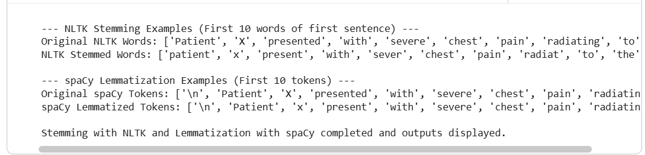
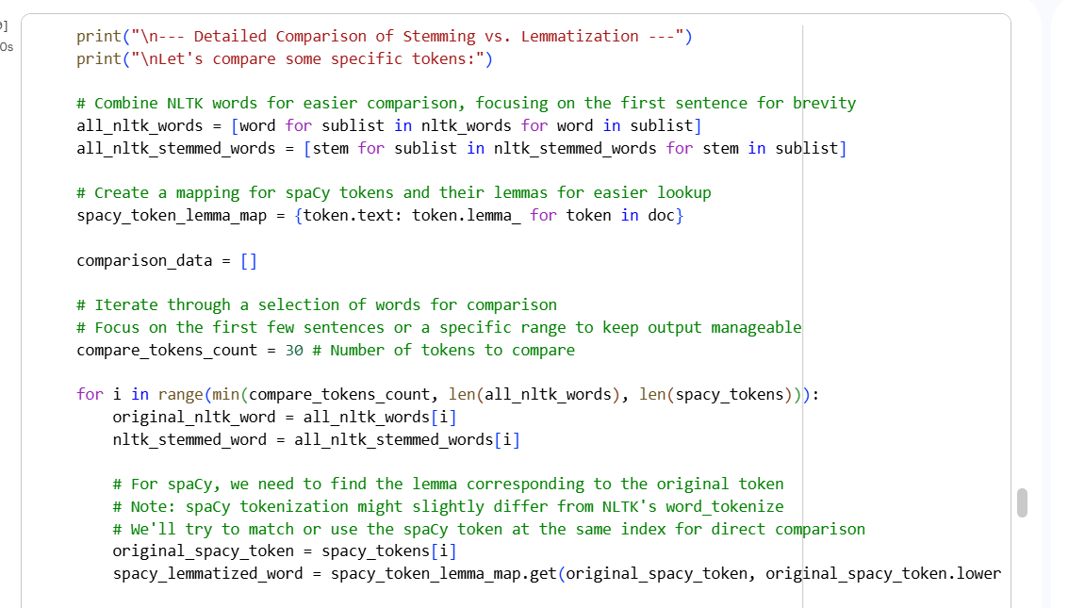
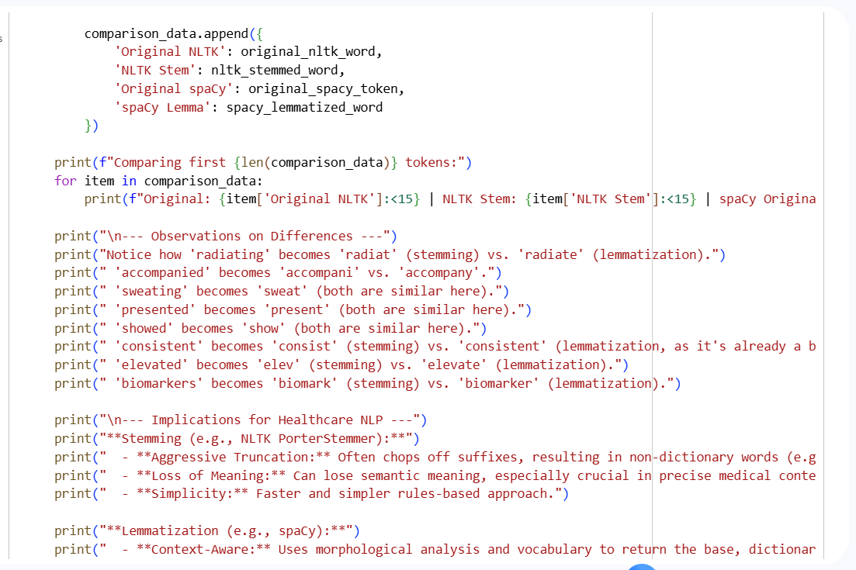
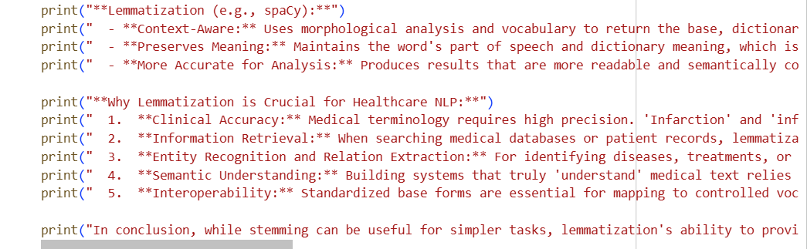
Output: